Installation of JavaFX for eclipse.

**STEP 01**

Make sure the eclipse is not entirely new version

Version of eclipse ide 2022-09 is needed

If the version is more new that 2022-09 it will not have the option to work JavaFX.

For example eclipse ide 2022-12.

https://www.eclipse.org/downloads/packages/ release/2022-09/r

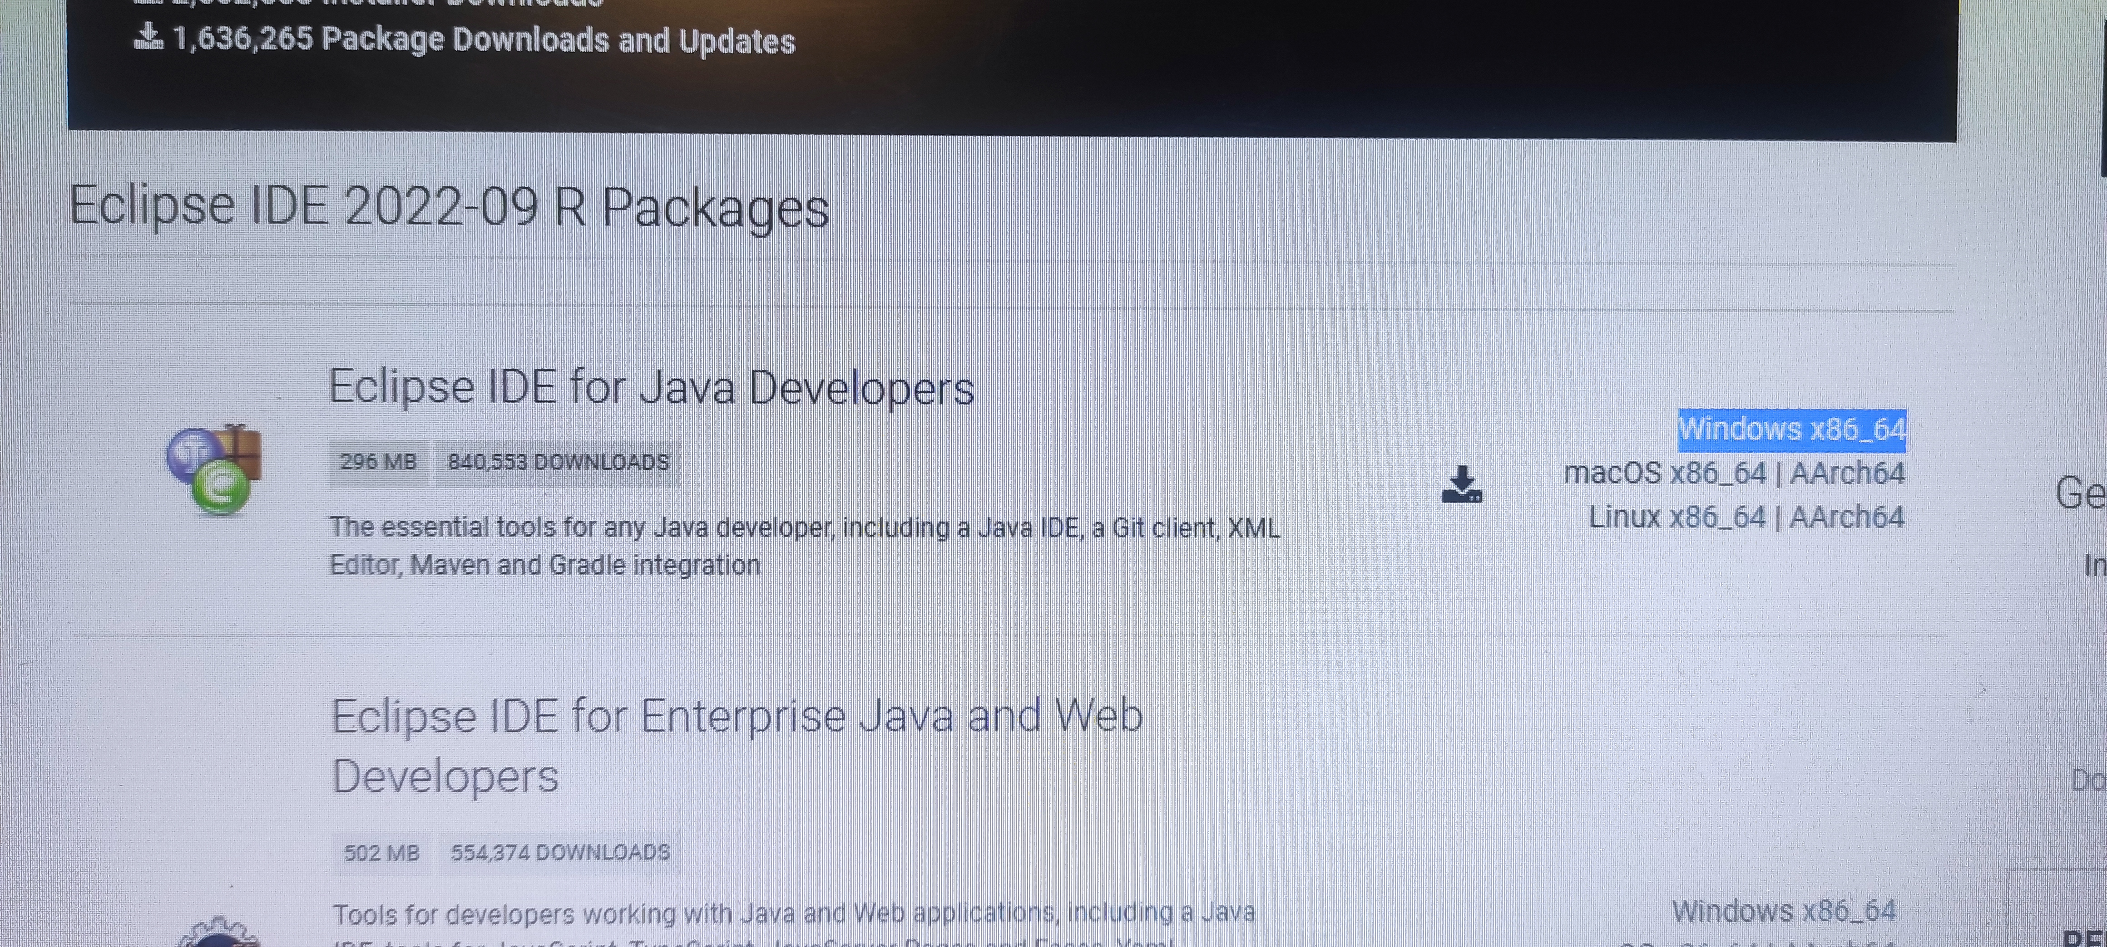

**STEP 02**

You have to check that which version of *jdk* you are using , To check this:

1. Go to the powershell.
2. Write this command (**java --version**)
3. Hit enter.
4. You will see an output like this.

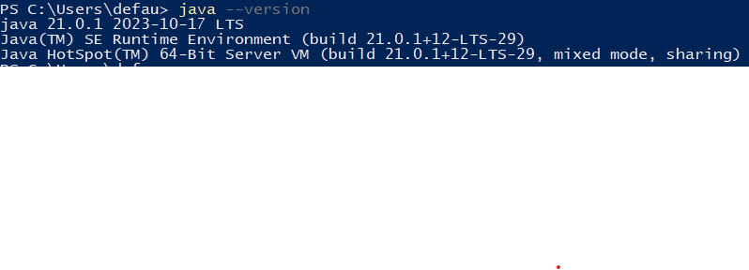

If you don’t see your output like this, It means your jdk is not installed. First you have to install your jdk and then proceed to the installation of **javafx**.

1. Now according to our jdk version, In this case my jdk version is (**21**) so I have to write it down some where because according to our jdk version we are going to download our javafx.

**STEP 03**

1. Then search on google JavaFX

And make sure the website is **(https://openjfx.io)**

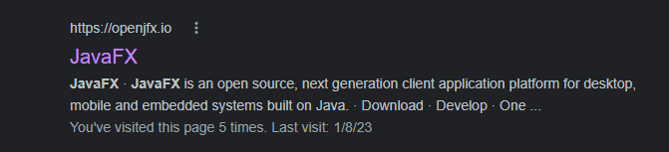

Or

just copy this link and paste it on the search bar of your browser:

**https://openjfx.io**

1. After opening the website scroll down until u see this

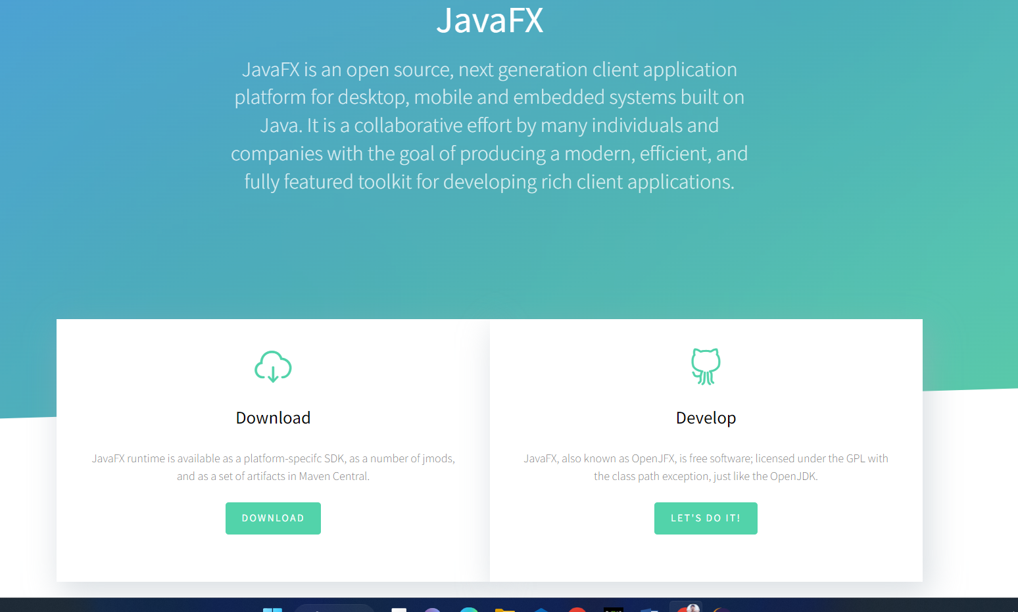

Click on download and it will open a new tab then scroll down till u see this 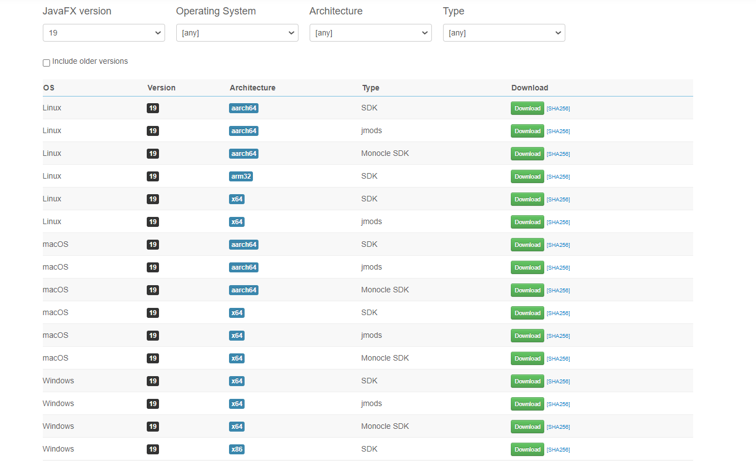

Now on (JavaFX Version) section, select that version of javafx which is equal to your jdk version.

In my case, My jdk version is 21 so I have to select (**21)** in JavaFx Version.

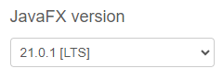

Now you have to select a file to download according to your operating system, in my case I have to download JavaFx file for windows. If you on linux just select linux file according to your distribution.

1. Now click on Download button make sure it is **SDK** you downloading.
2. Then go back to the tab where you searched javaFx and scroll down for a GUI Creator Tool for javaFx called **Scene Builder.**

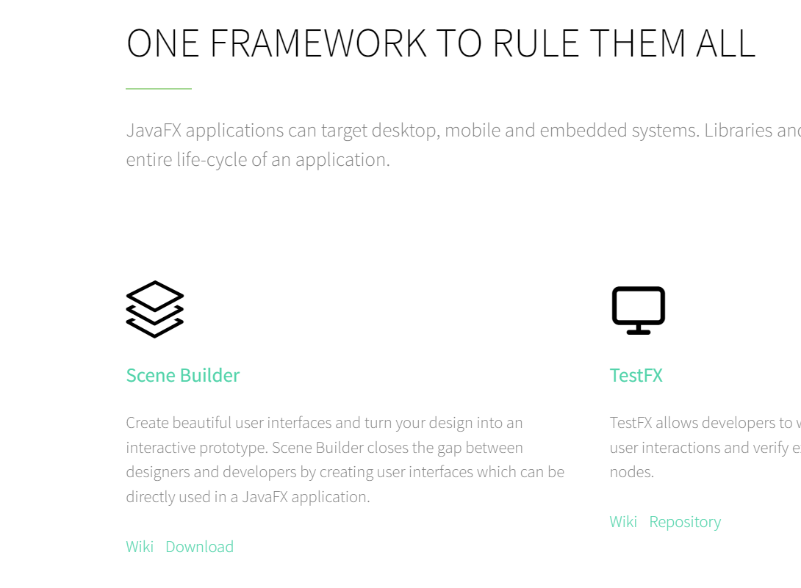

Now click on download button below **Scene Builder**.

A new tab will open , just click on **Download Now** button.

Select your download file according to your operating system and hit **Download** button same as JavaFX.

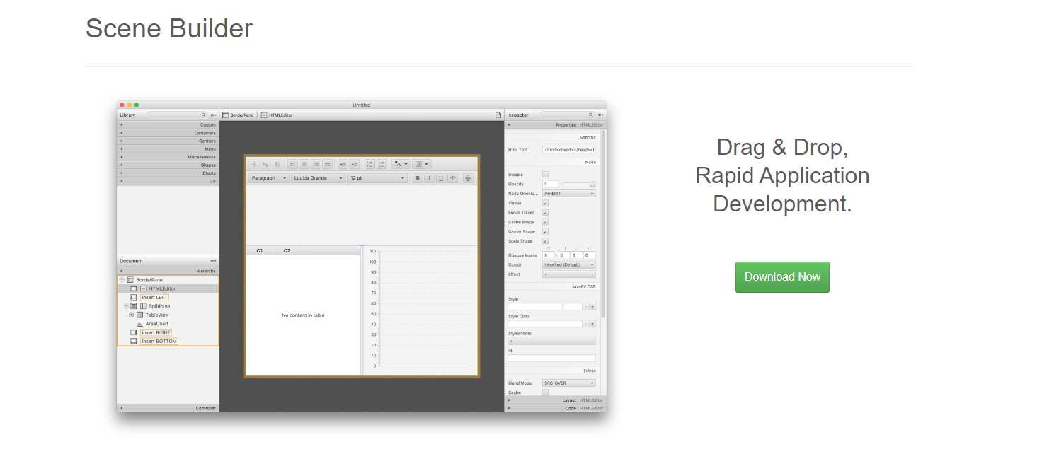

**STEP 04**

1. Now let’s take a look at the downloaded files,

(**JAVAFX SDK**) & **(SCENE BUILDER TOOL)**.

First, extract the file of (**JAVAFX SDK**) in anywhere you like, In this case I will extract the file in (**C** Drive) & that’s recommend for all windows user’s. Create a folder named (java) and in it , extract the (**JAVA SDK**)

Now let’s install our GUI Tool called Scene Builder.

You can install **Scene Builder** anywhere you like on your PC just like a normal application.

**STEP 05**

1. Now Open eclipse and click on help and then click on eclipse marketplace

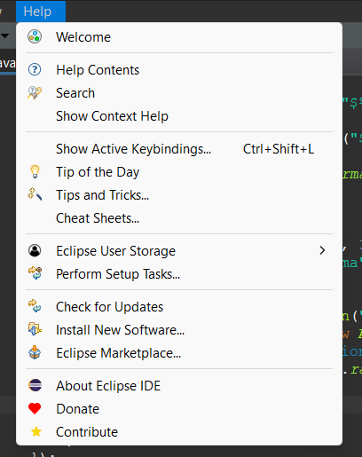

Then u will see something like this

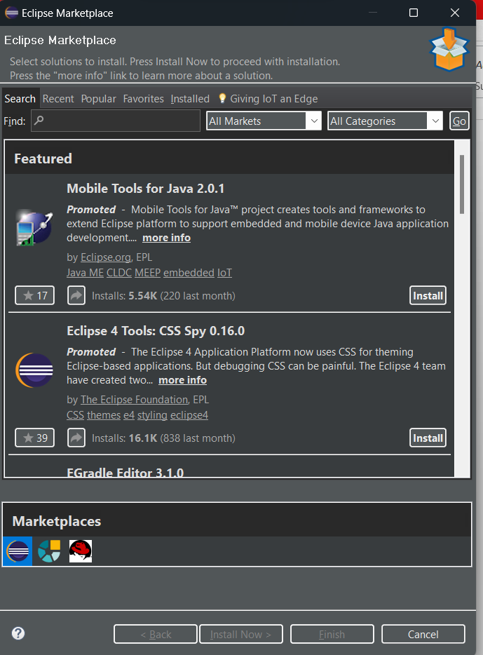

Search on find **javafx**.

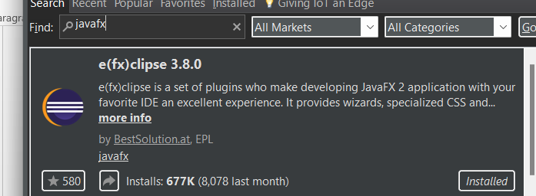

Install this and wait for it to install and restart the application.

1. After the plug in is installed and eclipse is open

Go on **window** and click on **preference**

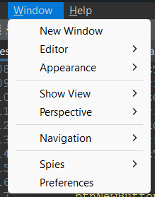

After that u will see something like this

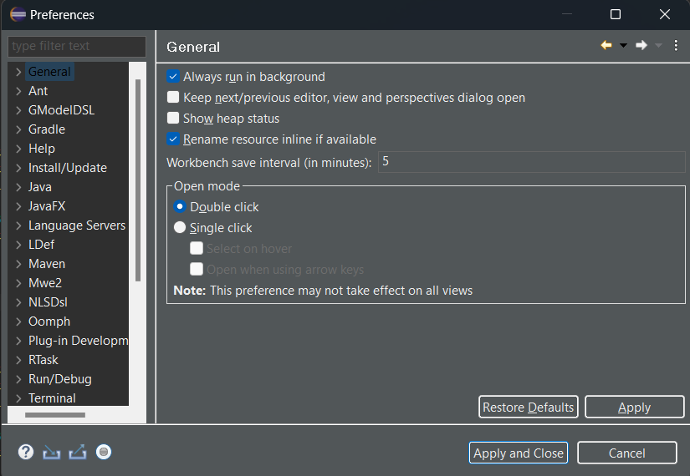

On the left side select JavaFx and the u will see something like this

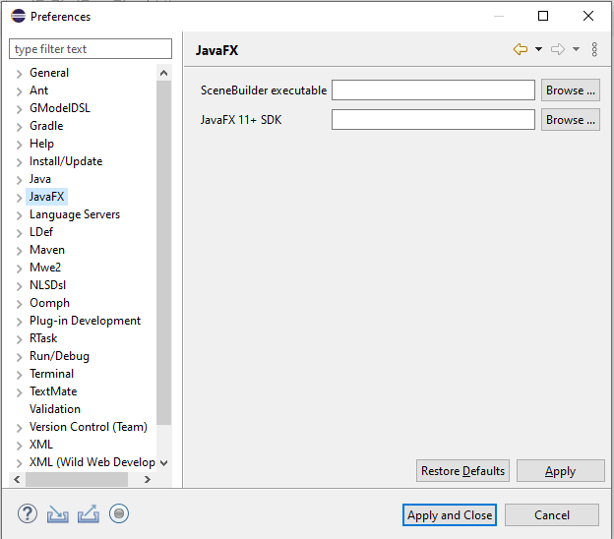

Now in **SceneBuilder executable** section, select (**.exe**) file of scenebuilder that you installed.

In **Javafx Sdk** section, select your javafx **lib** folder and then click on apply and close.

1. After that click on create project and then select javafx and in that click javafx project.Now set your project name,uncheck the **Module** options and select finish.
2. After that, open your “Main.java” file under **src>application** and then select **Run Configurations** on Run button options.

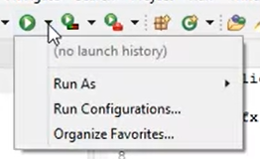

Then click on Run Configurations.

After you will see something like this

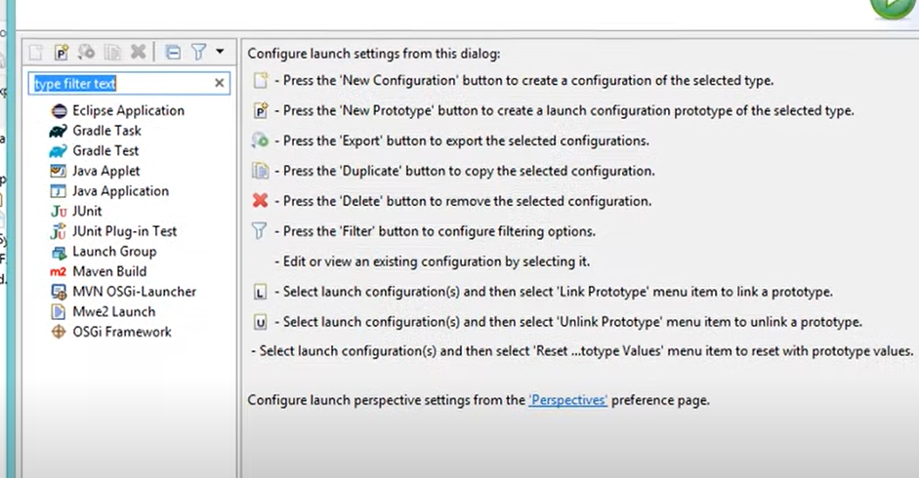

Right click on java application and then create a new configuration.

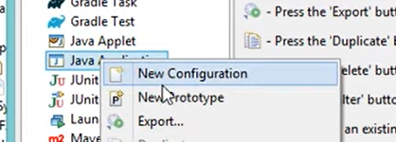

You will see something like this

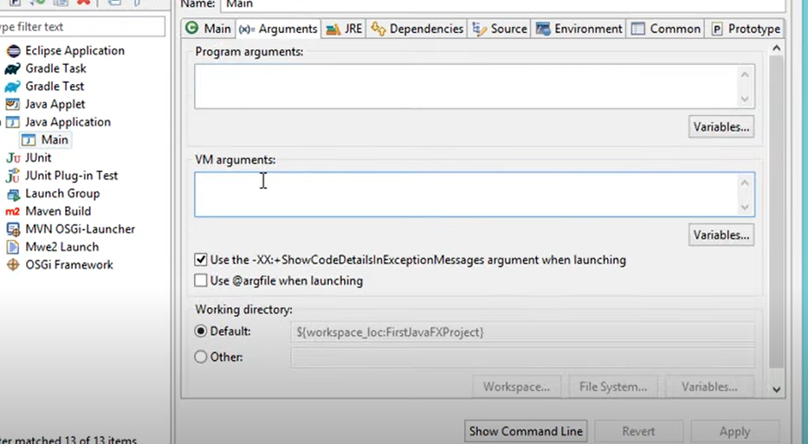

After that go back to google and open the tab that had the documentation of javafx and eclipse

Here’s the link: **https://openjfx.io/openjfx-docs/**

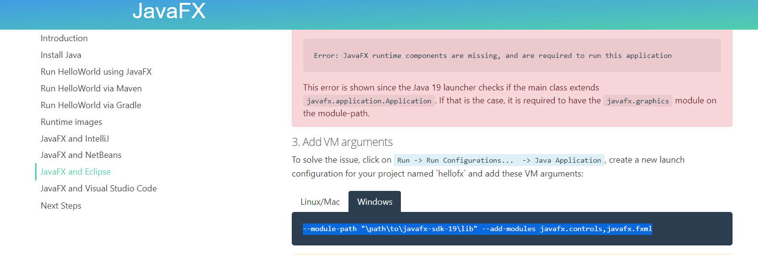

Select windows and copy this path in vm arguments

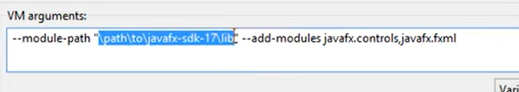

Delete the selected and then copy your location of the **JavaFX SDK lib** path in that from your pc for

And paste it in the double quotes.

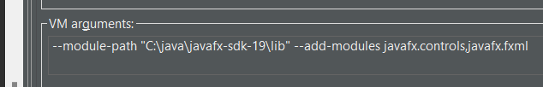

Then click on apply and close.

Now run your main.java file by pressing F11 or pressing run button. If you see a window opened , It means your JavaFX is successfully installed and working.

For more clear steps Here’s the link of YouTube video. <https://www.youtube.com/watch?v=Dbb69NiQHso>

Now you can use Scene Builder tool along JavaFX to create GUI applications.